[CprE 381] Computer Organization and Assembly-Level Programming, Fall 2017

Lab 5 Report

Name ____Larisa Andrews___________________________

Section /Lab Time ______F/Thurs 4-6 PM___________________

Refer to the highlighted language in the lab 5 instruction for the context of the following questions.

- [Part 1] 8-bit One’s complimenter (1 pt)
- Attach waveform screenshots
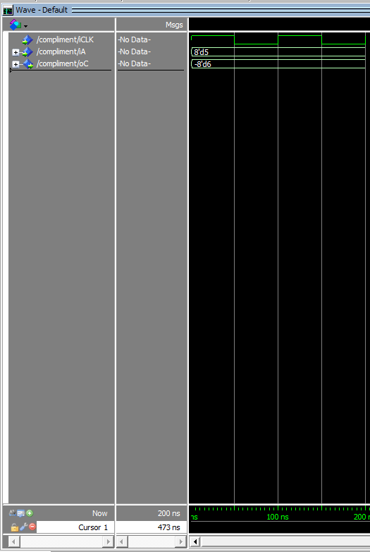
- Submit VHDL code

- [Part 2] 8-bit 2:1 MUX (1 pt)
- Attach waveform screenshots
  - 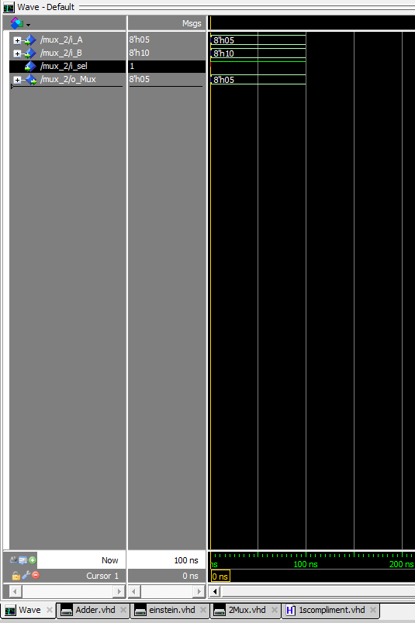
- Submit VHDL code

- [Part 2.b] Draw a truth table and K-map for 2:1 mux (2 pt)
(Even if you have chosen (a), you still need to do the followings)
- Truth table
- K-map
  - 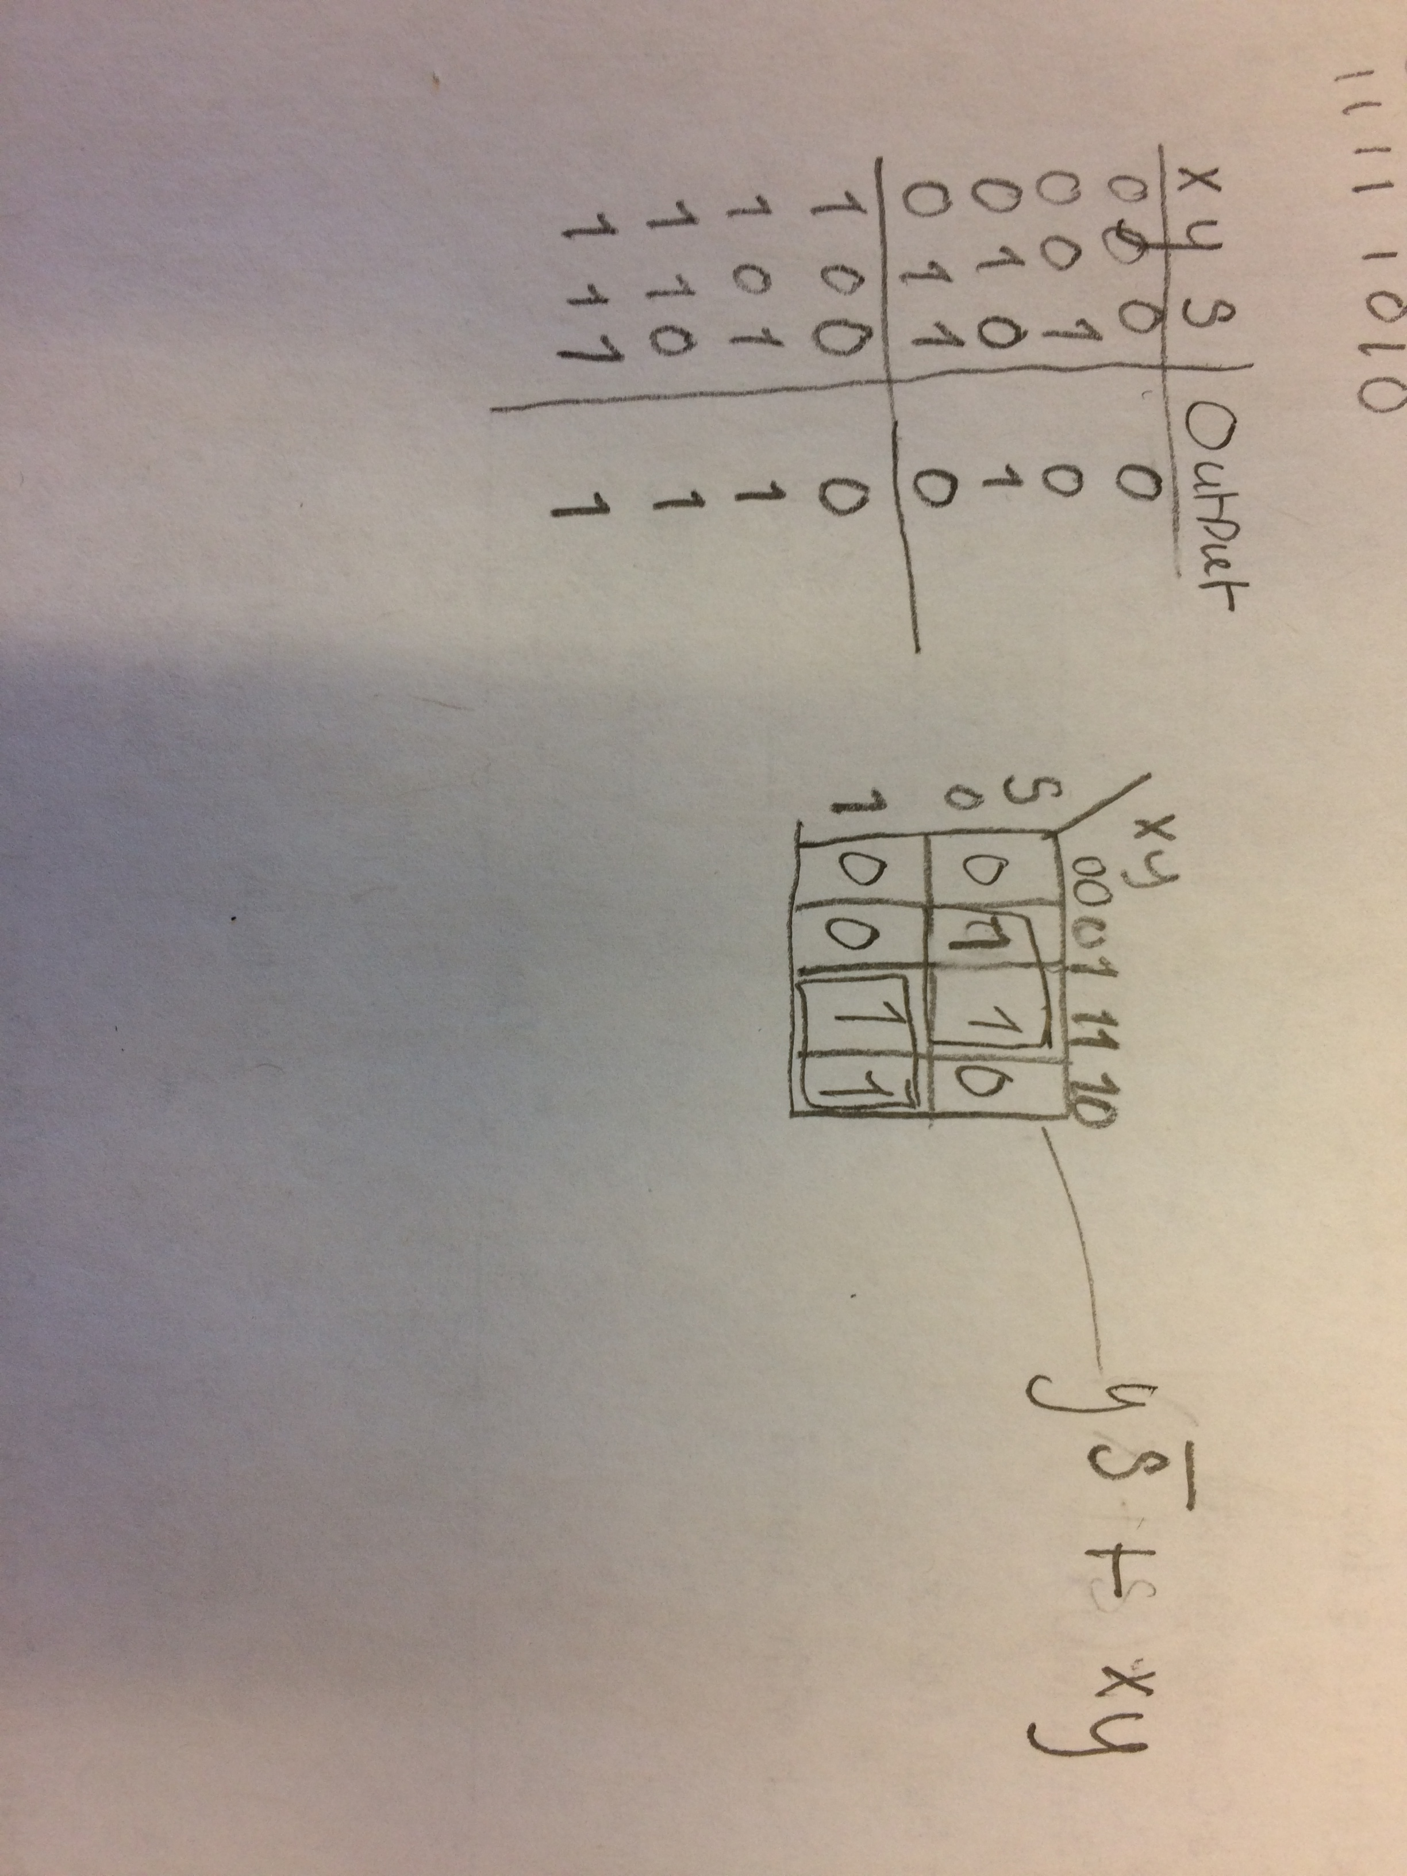
- Also, write down an equation for 2:1 mux
If x and y are your inputs and s is the select then the equation would be y(not)s + sx

- [Part 3] 8-bit full adder (FA) (1 pts)
- Attach waveform screenshots
  - 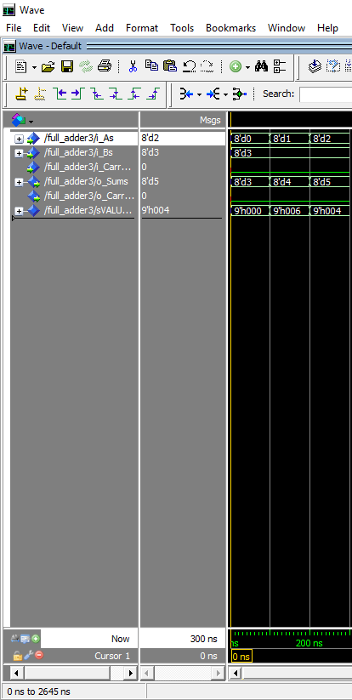
- Attach a screenshot of the schematic drawn on Quartus
  - Did not do Quartus
- Submit all codes (.bsf/.bdf and .vhdl)

- [Part 4] Add/Sub with Control (2 pts)
- Submit all codes (.bsf/.bdf and .vhdl)
- Attach waveform screenshots
  - 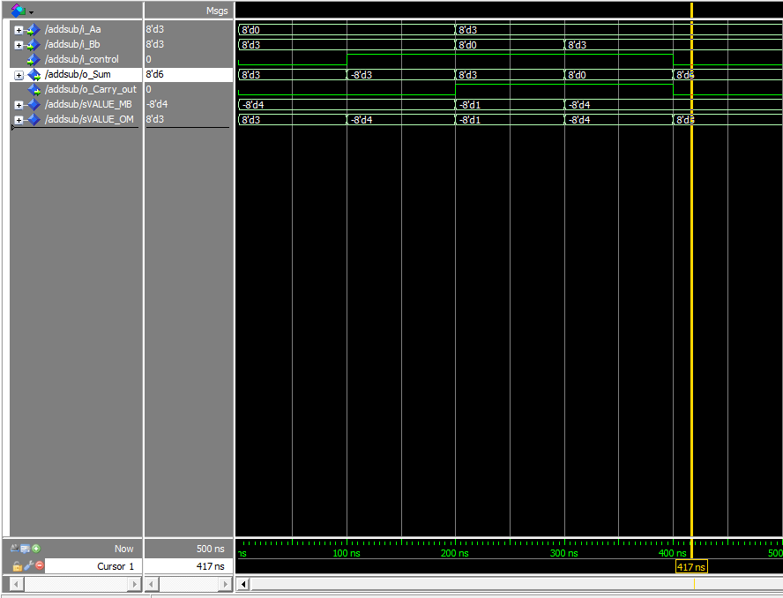

- [Part 4.a] Draw a schematic showing an 8-bit add/sub with control (1 pt)
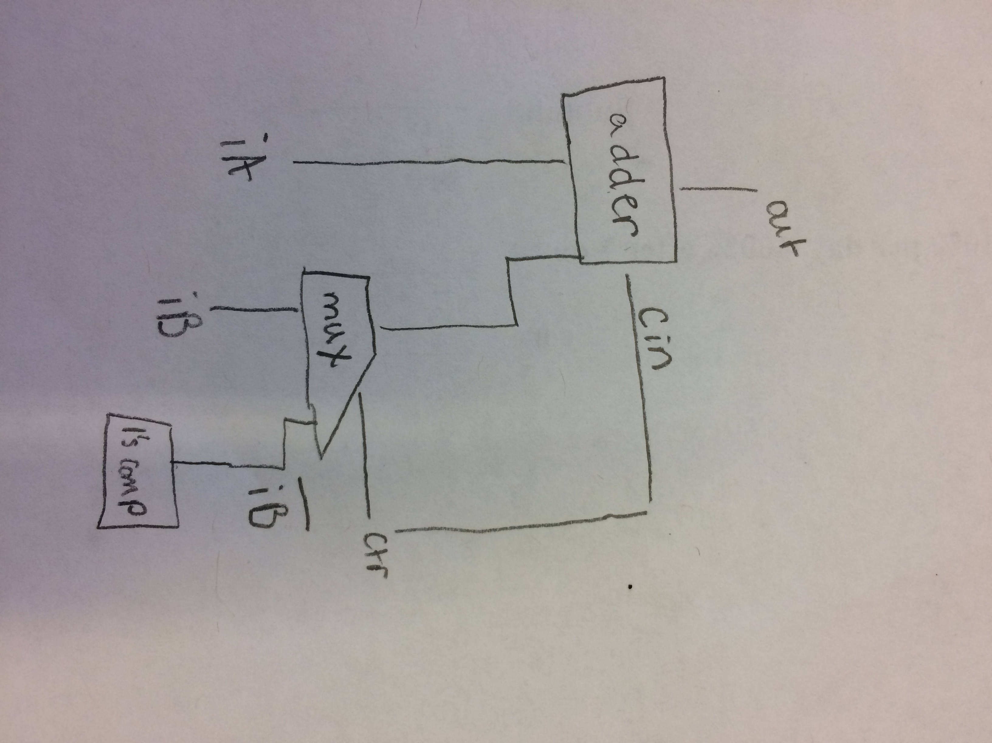

- [Part 4.a] How is the nAdd_Sub bit used? Please describe how your design performs A+B or A-B when nAdd_Sub is 0 or 1, respectively. (2 pt)

My designs performs A+B when nAdd-Sub is 0. When the bit is zero it just takes in the two values and uses the ripple carry adder to add them together and produce a sum. When the bit is 1 my design performs A-B, by using the 1’s Compliment-or to flip all the bits in B. My design uses a MUX to determine if 0 then normal B if 1 then (not)B. Then the 1 from the control is feed into the Cin of the ripple carry adder to add 1 to the A + negated B. This performs the subtraction.

